COMMUNITY RECREATION ASSOCIATION, INC.
W. MURRAY CRANE COMMUNITY HOUSE
400 Main Street
Dalton, Massachusetts 01226
(413) 684-0260
www.daltoncra.org

Flag Football League
Rules:
- This is an instructional league. No league standings are kept.
- Games will be weeknights and Saturday mornings at Pinegrove Park.
- Games will be (4) 15 minute quarters running time.
- All possessions will start on the 10 yard line.
- Each team will get 4 downs to get a first down 10 yards.
- A fumble will be blown dead on a bad snap/handoff unless the offense team picks it right up. Bad snap = play over.
- Teams will play 8 vs. 8 with 4 linemen, maximum rush 4 kids.
- Obvious penalties will be called so the kids learn the rules. Holding, clipping, tackling/offsides. Goal is for the kids to learn these rules.
- Kids on line should be matched up by size when possible. All kids should get a chance to run the ball.
- Games will be played in light rain. If heavy rain or not sure, call the CRA at 684-0260 - 1 hour before the game or check the Dalton CRA website at www.daltoncra.org.

League goals:
- For all kids to learn the basic rules of football.
- For all to learn, improve and have fun!
Good Sportsmanship from all!
Team | Coach | Coach Ph. Number | Coach Email
Packers | Chris Gallagher | 329-3995 | gallagher28@gmail.com
Patriots | Mike Hinkley | 441-2304 | mmghinkley@gmail.com
Giants | Paul Hermanski | 443-6216
Panthers | Mike Hagmaier | 684-1762 | michaelhagmaier@gmail.com
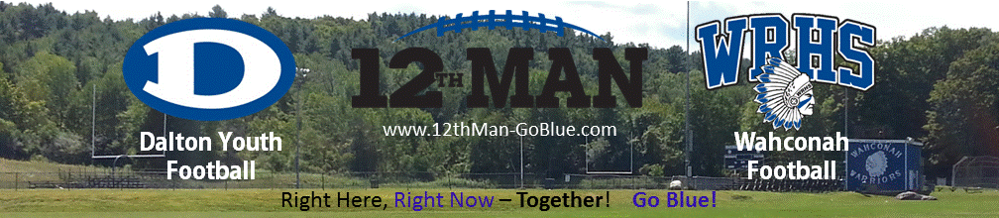

Flag Football Team & Coach Information:

Program Director: Dan McMahon; dmcmahon@daltoncra.org or 684.0260 x204
2016 Flag Football Schedule
Day | Date | Time | Team | vs | Team | Field
Thursday | 9/8 | 5:30pm | Packers | vs. | Giants | Pinegrove
Friday | 9/9 | 5:30pm | Panthers | vs. | Patriots | Pinegrove
Monday | 9/12 | 5:30pm | Giants | vs. | Panthers | Pinegrove
Wednesday | 9/14 | 5:30pm | Packers | vs. | Patriots | Pinegrove
Thursday | 9/15 | 5:30pm | Panthers | vs. | Packers | Pinegrove
Monday | 9/19 | 5:30pm | Giants | vs. | Patriots | Pinegrove
Wednesday | 9/21 | 5:30pm | Packers | vs. | Giants | Pinegrove
Saturday | 9/24 | 9:00am | Patriots | vs. | Panthers | Pinegrove
Monday | 9/26 | 5:30pm | Panthers | vs. | Giants | Pinegrove
Wednesday | 9/28 | 5:30pm | Packers | vs. | Patriots | Pinegrove
Thursday | 9/29 | 5:30pm | Panthers | vs. | Packers | Pinegrove
Saturday | 10/1 | 9:00am | Giants | vs. | Patriots | Pinegrove
Monday | 10/3 | 5:30pm | Patriots | vs. | Panthers | Pinegrove
Wednesday | 10/5 | 5:30pm | Packers | vs. | Giants | Pinegrove
Thursday | 10/6 |  | Youth Night ! Wear uniform! |  |  | WRHS
Tuesday | 10/11 | 5:30pm | Panthers | vs. | Giants | Pinegrove
Wednesday | 10/12 | 5:30pm | Packers | vs. | Patriots | Pinegrove
Saturday | 10/15 | 9:00am | Panthers | vs. | Patriots | Pinegrove
Wednesday | 10/19 | 5:30pm | Patriots | vs. | Giants | Pinegrove
Saturday | 10/22 | 9:00am | Giants | vs. | Packers | Pinegrove
 |  | 11:00am | Patriots | vs. | Panthers | Pinegrove
Saturday | 10/29 | 1:00pm-2:30pm | End of Season-Pizza & Pool Party |  |  | CRA

Program Director: Dan McMahon; dmcmahon@daltoncra.org or 684.0260 x204

